SafeIn5.ai –Workflow MVP Review / Phase 2 Summary Review
Enterprise Observation PULSE | Enterprise Work Task PULSE | Community Observation PULSE

Discussion Point – Work PULSE Job Capture, Team Observations & Offline Use
During 4 site visits over the last two days, I have spoken to various site managers and supervisors and one of the sites, a Tarmac site in Wales, Dolyhir may be part of the MVP as they have two plants on site an asphalt plant and aggregrate plant. Concerns have been raised about the challenge of assigning jobs to workers/users via the back office client admin during MVP. I see this as a potential risk to MVP success, therefore I have reviewed a few alternative options and come up with the following for further discussion:
Discussion principle: Assigned jobs should reduce friction, not be a prerequisite for using Work PULSE. A worker must always be able to start a PULSE or make an Observation even where the job has not been created in SafeIn5 or the device is offline.

Proposed Work PULSE Entry Flows

1. Assigned Job – CURRENT FLOW
Home → Start Work PULSE → Select Assigned Job → [NEW: Confirm Location] → PULSE
2. Job QR – CURRENT FLOW
Home → Scan QR → Job + Location Identified → PULSE
No significant change
3. Space / Asset QR – CHANGE
Home → Scan QR → Space/Asset + Location Identified → [NEW: Identify Job by Assigned Job / Photo RAMS-Permit / Voice] → PULSE
4. No QR / No Assigned Job – CHANGE
Home → Start Work PULSE → [NEW: My Job Isn't Shown] → [NEW: Confirm Location] → [NEW: Photo RAMS/Permit OR Say the Job] → PULSE

Observation
5. Observation Linked to Job – CHANGE
Observation → Photo/Video + Voice → [NEW: Confirm Location] → [NEW: Related to Work? YES] → [NEW: Select/Confirm Job] → Share → Linked Observation Echo
6. Normal Observation – SMALL CHANGE
Observation → Photo/Video + Voice → [NEW: Confirm Location] → Related toa Current Work Task? NO → Classify → Share → Observation Echo

Offline
7. Offline – Job Known – NEW
PULSE/Observation → Cached Job → Capture → Store Offline → Sync Later
8. Offline – Job Not Known – NEW
PULSE/Observation → Photo RAMS/Permit OR Say Job → Capture → Store Offline → Link/Sync Later

Phase 2
9. AI Job Assignment
RAMS/Permits/Work Pack → AI Identifies Jobs + Locations + Teams → Supervisor Approves → Jobs Assigned
10. Integration
Client Work/EHS System → SafeIn5 → Job Automatically Available → PULSE

Stage / screen | Proposed MVP workflow | What SafeIn5 captures / does | Reason
1. Home screen | Retain the three existing routes: Observation / Scan QR / No-QR Work PULSE. | Determines which PULSE journey is being started. | Avoid redesigning the home screen.
2. Location | Establish/confirm location when starting either an Observation or Work PULSE. QR provides location automatically where available. | Site + location/space/asset where known. | Location is important context for every Echo/PULSE.
3. QR Work PULSE | QR may identify a space/asset or a specific job. Use whatever context the QR provides. | Location/asset and, where available, job information. | QR should remove input, not create more steps.
4. No-QR – assigned job exists | Continue to show jobs assigned by the back office. Worker taps their job and continues. | Uses existing job record and assignment. | Retains the functionality already developed for clients that want job assignment.
5. No-QR – job not assigned | Add “My job isn’t shown”. Worker can photograph RAMS/HIRA/permit OR say what job they are doing. | Creates a lightweight job/Work PULSE context from the worker’s capture. | Worker must not be blocked because nobody created the job in the back office.
6. Minimum job context | Do not require a complete job record. | Minimum: what work + where + who/team + available document/reference. This could be included as prompt text instructions. | SafeIn5 needs context for PULSE, not another work management system.
7. First PULSE creates active job context | Where no job existed, starting the first Work PULSE creates the active job/PULSE record. | Example: Tank 3A – Entry · Tank 3A · Permit photo · Team A. or John Smith, etc etc | Allows paper-based sites to use SafeIn5 without daily back office administration.
8. Work PULSE | Continue through the existing Pause → Uncover → Learn → Shift → Echo workflow. | All activity remains linked to the parent Work PULSE/job. | No redesign required to the core PULSE.
9. Observation during work | Any worker can use normal Observation capture. If several jobs are active, ask whether the Observation relates to work and allow the worker to identify the relevant job. | Observation Echo becomes linked to that Work PULSE/job. | The person making the Observation may not be the person who started the PULSE.
10. Several jobs on site | Where SafeIn5 knows the active jobs, present a short list, e.g. Tank 3A – Entry / Conveyor 4 – Repair / Hot Bins – Maintenance. Include “My job isn’t shown”. | Worker selects the relevant job without needing individual assignment. | Important for shutdowns and sites with several simultaneous jobs.
11. Offline – job already cached | Previously synchronised job/location information remains available on the device. Capture the Observation normally and synchronise later. | Store locally until connection returns. | Supports SafeIn5’s offline-first requirement.
12. Offline – job not known to device | Do not block the Observation. Worker photographs relevant paperwork or says what job it relates to. | Store Observation + location + job description/document locally. Reconcile/link when connectivity returns. | One offline device cannot know about a job created on another offline device.
13. Back office / SIGNAL | Job, Work PULSE, Shift Echoes, previous-Echo responses and linked Observation Echoes are presented as related information. | Creates the complete behavioural picture around the work. | This is where the richer job intelligence becomes valuable.
14. Phase 2 – AI Job Wizard | AI reads daily RAMS/HIRA/permit/work packs and proposes jobs, locations, assets and team assignments for supervisor approval. | Upload → AI creates suggested jobs → supervisor approves. | Removes much of the future administration of job creation/assignment.
15. Phase 2 – integrations | Receive jobs from FYLD/EHS/permit/work-management systems where clients already have digital workflows. | Automatically imports job context and assignments. | Avoids duplicating existing client systems.
Review of Current Workflows:
Workflow / area | Suggested workflow changes for MVP | Wording changes for MVP | Phase 2 – include / capture
Enterprise – Observation PULSE | My Echo/history clearly identifies this as an Observation PULSE rather than Work Task PULSE. | Use conversational AI confirmation, e.g. “This looks like something people need to be aware of. Is that right?” Voice prompt: “Tell us what you saw”; transcript: “You said…”. | AI suggests Good Practice / Be Aware / Needs Attention Now from media + transcript; worker confirms or changes. Ensure  Automatic themes/categories; SIF potential indicators; positive-practice recognition; recurring observations; clustering; suggested Learn5; routing/action recommendations.
Enterprise – Work Task PULSE / Uncover | Required Learn5 sits at top of check sequence and is automatically ticked after completion. Remaining checks require positive confirmation. Distinguish not checked yet from actively identified as not right. Only an active failed check triggers exception/Echo route. | “Something not right – share it” should only appear after an active failed check, not because checks remain incomplete. Keep task prompts short and specific. | AI interpretation of failed checks; recurring task problems; comparison across sites/jobs; dynamic checks/Learn5 based on task risk; predictive warnings from previous Echoes.
Enterprise – Work Task PULSE / Shift & Echo | Hazards/observations during the job become separate Observation PULSE Echoes. This needs to be demonstrated or understood for engineering | Shift wording should ask what changed because of the PULSE. Clearly distinguish task update / Shift / Observation in the interface and My Echo. | AI identifies meaningful Shift changes, repeated/ineffective controls and unresolved updates; links “still not repaired” to earlier Echoes; closure validation and previous-Echo resurfacing.
Enterprise – Work Task PULSE / Completion & No-QR | Completion represents the whole PULSE: checks, Learn5, Shift, mini Echoes and related observations for one job. If no-QR work, use RAMS/permit/document photo to identify the task without making workers navigate organisation structures. Confirmation that Photo of RAMS will link the RAMS to the no QR work task Work Task page if not showing the job can capture the job and then continue with PULSE. If none of the list is their job then how do they continue to link a PULSE to a Job. | Remove unnecessary duration/backend detail. For no-QR: “Show us the RAMS or permit for this job.” | PULSE timeline and effectiveness analysis; AI document extraction of task/location/controls/version; compare RAMS/permit requirements with frontline reality.
Community – Observation PULSE | Normal route: Camera → photo/video → What did you see? → voice/transcript → AI suggests category → user confirms/changes → Share → moderation → Community Feed. Manual category selection becomes fallback, not default. | Camera: “Show us what you see” / “Take a photo or video”. Description: “What did you see?” + “Tell us, or type it instead.” Voice: “Tell us what you saw.” Transcript: “You said…”. | Multimodal understanding; automatic headlines/summaries; deeper internal categorisation; geographic/trend analysis; recurring hazards and community safety intelligence.
Community – Categories | AI presents suggested category first. Recommended visible categories: Roads & Paths; Places & Facilities; Environment; Personal Safety; Public Safety; Something Else. Something Else continues without another questionnaire. | Replace “What kind of issue is it?” with “What is it about?” Example: “SafeIn5 thinks this is: Personal Safety. Is that right?” Replace “Infra”. Avoid “Unsafe Behaviour”. | Deeper hidden taxonomy; learn from Something Else; AI confidence; distinguish positive behaviour, personal safety actions and wider public-safety conditions.
Community – Review, Feed & Moderation | Before sharing, show lead media + visible transcript/description + AI category. Feed should show meaning/headline rather than require audio playback. Separate SHARED confirmation from public publication so moderation can run first. | Replace “What is being shared by you” with “What you’re sharing”. Consider “Community Feed” rather than “FEED”. Use useful observation headline/summary rather than “Shared from the camera”. | AI privacy moderation/redaction; faces/children/registrations/PII handling; trust/duplicate checks; local/personalised feed; related Echoes; acknowledgement/resolution feedback loop.
Community – Learn5 | Do not add a compulsory Learn5 step to every Community observation. Allow a relevant Learn5 to be surfaced after the observation has been understood/categorised, where useful. | Use light contextual wording such as “This might help…” rather than formal training language. | Contextual Learn5 from library based on observation/category/location/circumstances; support scenarios such as family/beach safety; later proactive/personalised safety learning.
ALL 3 – Share screen Transcript | Standardise voice capture: voice → visible transcript → edit/re-record → continue. Voice primary; typing secondary (community only).

Suggested Amendments to Workflows
Changes to review, in addition to the above.

# | Change | Why it matters
1 | Add a standing “Can’t proceed” entry point, if the job has to stop for any other reason outside of a presented check list so separate from the checklist. Route: tap “Can’t proceed” → blocker category screen (same pattern as the existing “What’s not right?” screen, with categories like Access/Permit, Materials/Equipment, People/Resourcing, Environmental, Something else, plus voice note) → “Stop the job” → lands on the existing JOB STOPPED / “shared as an echo” screen | The current “Something not right” flow is anchored to a specific checklist item (e.g. tapping into “Rescue equipment setup” shows sub-options for that item only). Blockers with no checklist item — no permit, missing materials, plant not on site — have nowhere to go and get misclassified as Observations. The JOB STOPPED terminal screen is already generic enough to reuse as-is.
2 | Lock classification rule: For MVP – worker observation the user selects one of 3 categories for Phase 2 AI will suggest.  For community observation AI assist suggests category

Additional Missing MVP Requirements
Further gaps identified across the three flows, not covered by the amendments above.

# | Missing requirement | Why it's a gap
1 | QR scan failure fallback, distinct from the planned No-QR route | The doc covers “no-QR work” as a deliberate path (RAMS/permit photo as above suggested). It doesn't cover a QR code that exists but is damaged, dirty, or won't scan on-site — a different failure mode that shouldn't dump the worker into the full no-QR RAMS/permit flow if the job is otherwise QR-tracked. This will be picked up as part of the above discussion.
3 | Checklist “Not applicable” state | Uncover checks currently have checked / unchecked / actively-failed. There's no N/A. Once a job has been assigned then this will determine the checklist if applicable. This will need to be AI assist once the job is known.
4 | Permit/RAMS expiry or shift-boundary re-validation | The initial PULSE covers the uncover, shift & Echo to report meaningful changes during the job. Thereafter then other reportings about the job are observations linked to the job. Make the assumption that if the job continues then all other reports will be observations for MVP.
5 | Location capture for Community Observation | The Community flow (Camera → description → voice → AI category → Share) never mentions capturing location, yet the visible categories (Roads & Paths, Places & Facilities, Environment, Public Safety) all depend on it, and it's the basis for the “geographic/trend analysis” listed as Phase 2. This needs to be an MVP capture step, not just a Phase 2 analytics input.

Testing On Sites:
The following might be demo software issues due to restrictions on presentations screens:
- Screen sizes on Iphone 17 Pro, cant see all screen wording
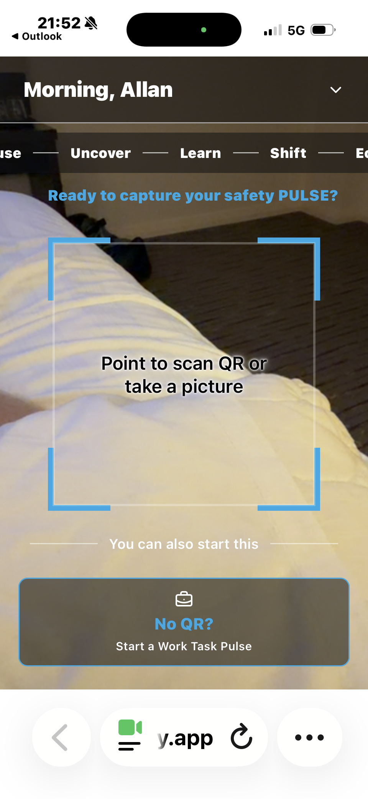

- Zoom in camera and video moves the whole screen settings:
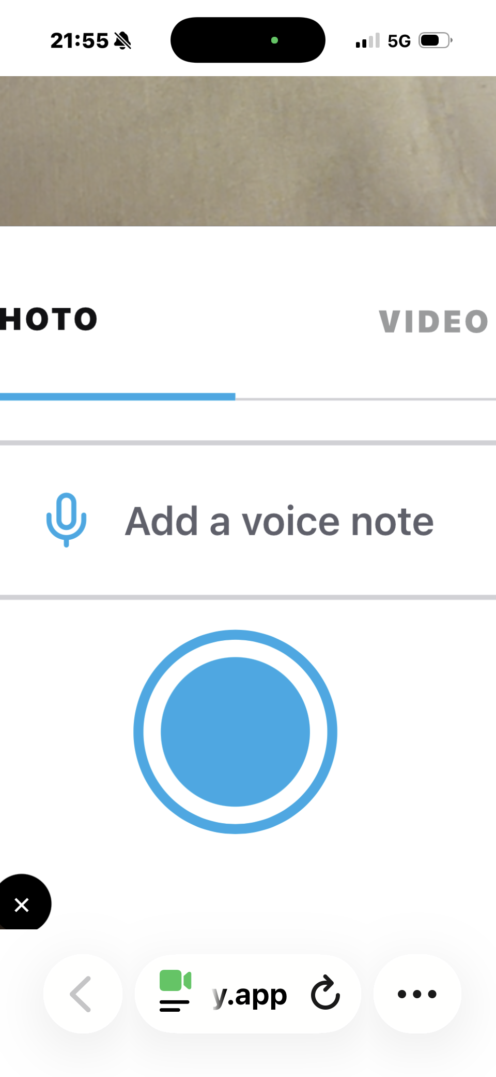

- Screen sizing

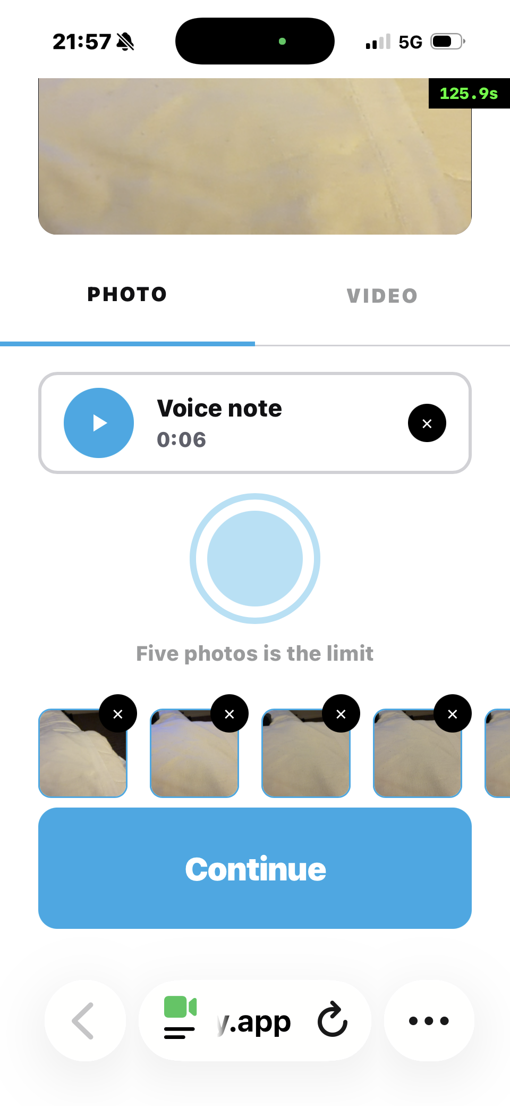

- Screen below jumps when clicking on check box
